**Curriculum­­­ Vitae**

**Ery Aswadin**

**Phone : 081411066073**

**Email :** [**fudcca@gmail.com**](mailto:fudcca@gmail.com)

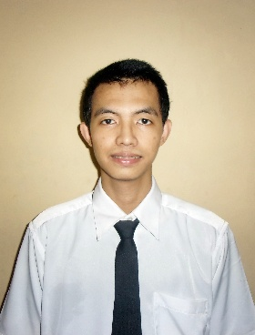

* **Summary**

More than 6 month experience in PT.Ondewin/Neptunus Tours and Travel as Ticketing domestic and International Flight & Online System.

* **Personal Details**

**Name :** Ery Aswadin

**Gender :** Male

**Date of birth :** November, 16, 1994

**Address :** Pondok Safari Indah Jl.Seruni No3, Bintaro

**Phone :** 081411066073

**Email :** [fudcca@gmail.com](mailto:fudcca@gmail.com)

* **Academic**

**Backfround :** 2009-2012, 86 Senior High School, Bintaro

( Attended 2009 Class of 2012 )

: 2014-Present, Universitas Negeri Terbuka, Jakarta

S1-Ilmu Komunikasi

**Computer Literaty** **:** Ms-Office, Adobe CC, Python, SQL, JavaScript

**Language** **:** Indonesian, English, Arabic